**WEB-BASED ALS LEARNING MANAGEMENT SYSTEM WITH**

**PERSONALIZED LEARNING RECOMMENDATIONS**

**IN BULAN, SORSOGON**

Francine F. Gludo, Jhonpaul G. Corong, Wilfredo Jr H. Magollado, Ronil

Malapote

College of Information and Communications Technology

Sorsogon State University - Bulan Campus

Bulan, Sorsogon

Emails: corongjhonpaul@gmail.com; gludofrancine95@gmail.com; wilfredojrmagollado970@gmail.com; ronilmalapote123@gmail.com

# 1 Introduction

This chapter presents the introduction, the project context, its purpose and descriptions, objectives and the scope and limitations of the study, aiming to explain the importance of the project.

## Project Context

In the world of modern technology, learning management systems are

increasingly being used in school intended for alternative learning of the students in times of postponed classes due to school conditions after a calamity such as flooding, hectic schedules of teachers and scheduled school events. However, learning comprehension or slow learning is one of the problems encountered by some students, primarily ALS students because of the gaps in their foundational knowledge and skills, their preferred learning preferences and lack of learning contents and materials. The statement of [4], students with slow learning comprehension will face too many difficulties that can cause low learning effectiveness and loss of interest in studying.

In the Municipality of Bulan, Province of Sorsogon, many schools including the Bulan National High School wherein the ALS (Alternative Learning System) is located, they are experiencing calamities, lack of classrooms and resources or materials because of postponed classes, limited class hours and schedules that causes limited learning of students that affects their studies and for educators to demonstrate effectively their lectures.

The Senior High School of ALS in Bulan National High School is a program for out-of-school youth and adults that wants to continue learning despite their ages and status in life. ALS classes is limited; they only meet one (1) to two (2) days a week for every six (6) hours. Due to limited classes and hours, the teachers can’t demonstrate properly their lectures and the students’ learning are lacking. So that, the development of “Web-based ALS Learning

Management System with Personalized Learning Recommendations in Bulan,

Sorsogon” will be an effective alternative learning platforms for students to have an access with the lessons and topics given by their teachers wherever they are, as well as to catch up to their current lessons or topics based on their curriculum. And for teachers to post or upload their learning materials.

Implementing a learning management system is important to improve and enhance the learning experiences of students and teaching techniques of teachers. It enables teachers to provide customized content for students’ needs to use and apply a variety of pedagogical models, and to engage with their students effectively, especially for those students that have a learning comprehension problem, which is serves as a crucial link between current education improvements and effective uses of technology [1][3]. This system is crucial for ALS because it will help them conveniently engage with their education and connect to the latest technologies.

The systems provide automated recommendations for students to meet their learning style and preferences or more comprehensive learning because the knowledge and skills of some ALS students have a gap such as lack of expansion of knowledge and forgetting past lessons, also some students are slow learners that need to be assessed. For automated recommendations, the item-based collaborative filtering is a type of recommendation engine that will be used to specifically recommend or suggest learning materials together with the result of the assessment like quizzes or other forms of test activities taken by the students that will be uploaded by the teachers. As for the teachers, they

can have the ability to create, manage accounts and learning strands (LS) providing many multimedia format resources that they are unable to demonstrate in classrooms due to limited class schedules. While the admin can have the ability to maintain the functionality of the system, checking errors then debug.

## 1.2 Purpose and Descriptions

A Web-based ALS Learning Management System with Personalized Learning Recommendations in Bulan, Sorsogon, including Senior High School students, aims to provide accessible educational resources, materials, and subjects for efficient self-learning activities that support the unique educational needs with a personalized learning pathway for ALS Learners. It will include features such as uploading course modules, quizzes, adaptive learning paths based on user assessments, flexible assessment system allowing users to submit answers through multiple formats (text, audio, video) and communication tools to bridge the gap between students and educators. Moreover, the system features a user-friendly interface that allows students to navigate through different subjects and participate in interactive learning activities. Teachers can upload educational content, manage student performance, and provide feedback through an integrated communication module. The platform supports various multimedia formats, including text, videos, quizzes, and downloadable materials, ensuring a comprehensive learning experience.

Learning Management System for ALS is a platform for delivering educational services to out-of-school youth and adults. The system plays a crucial role in increasing access to education, improving learning and teaching experiences and enhancing knowledge through technology. This study is deemed significant to the following:

To ALS Students. The study will provide a comprehensive and efficient learning system through a web-based learning management system to enhance the learning experiences, knowledge and skills of the students.

To ALS Teachers. The study aims to provide easy and modern alternative teaching techniques by creating and uploading learning materials and contents through the system.

To Admin. The study aims to provide a learning management system with personalized learning recommendations that needs to be well maintained and ensures that work smoothly throughout monitoring of the system after deployment.

To Proponents. This study will enhance the knowledge, skills, and critical thinking of the proponents on how technology can support learning and education.

To Future Researchers. The study will help them build upon the findings gained from the current project and learn how important a Learning

Management System development.

## 1.3 Objectives of the Study

This study aims to design and develop a Web-based Learning Management System with Personalized Learning Recommendation in Bulan, Sorsogon.

Specifically, it sought to:

1. To determine the information requirements of the proposed system for a user-friendly web-based Learning Management System for ALS students, promoting self-paced learning and engagement.
2. To design and develop a Learning Management System that enables:
   1. Management of activity, assessment, learning strands content, accounts, and scores.
   2. Implement recommendation engine
   3. File resources sharing (e.g. PDF files, presentations, images, and video links that relevant to the ALS learning strands)
3. To evaluate the proposed project, based on ISO/ IEC 25010 Software

Product Quality, in terms of.

* 1. Functional Suitability
  2. Interaction Capability
  3. Reliability

## 1.4 Scope and Limitations of the Study

This project focuses on the development of a web-based learning management system for Senior High School ALS students in Bulan National

High School in Bulan, Sorsogon using HTML5, CSS, JavaScript, and Bootstrap5 for its framework as well as for front-end development. While, for the back-end development PHP 8.1 with Laravel 10 will be used for its functionality and simplified development. In addition, MySQL 8.4 is also use for its database where in the data of all users are being stored. This covers GAS

(General Academic Strand), and its Learning strands (subjects) focused on Senior High School students only.

The ALS students and ALS teachers will register or sign up first to the system if they still don’t have an account. Creation of learning strands and adding its content is also for teachers only so that, students will access and download educational resources uploaded by their teachers in different multimedia format including text, pictures, and videos, take assessments that provide automated material recommendations to suggest which part of the lesson as the students have difficulties as part of its result, submit activities and projects that will be reviewed and give feedback by the teachers and track ALS students’ performance. The proponents will be the admin of the system that is responsible for checking errors and debug to maintain its

functionalities.

The system delimits its scope for printing grades, posting school events, and SMS notification functionality because the focus of the system is the recommendation engine wherein it will be allowing students to have a

personalized learning paths in studies by using the item-based collaborative filtering as a type of algorithm to implement properly the recommended learning pathways as well as the learning materials for ALS students. The mentioned functionality above did not belong to the main objectives of this study.

# 2 Review of Related Systems

This chapter provides review of various related literatures and systems that reinforce this study about learning management system. This includes the review on information requirements and features of the system.

The learning management system developed by Kankunta [1] is an

online web application that supported two (2) different roles with the feature of in-app payment using the users credit/debit card. The instructor is capable in creating, update and disable course and upload learning materials. Additionally, the profits can view in the dashboard when the students purchased. The student role is to view list of courses, a brief description of the course and the name of the instructors of the courses they purchase. The system used Bootstrap, jQuery, JavaScript, and HTML5 for the frontend module, while Java and Spring boot MVC is being used for the backend. Also, MySQL is used for storing users’ information and course data.

The Learning Management System of Kankunta [1] and the current

proposed project has similarity in terms of its goal, since they both aimed to make teaching and giving lessons to students make easier for instructors.

However, the current project has three (3) different roles, the student, teachers and the admin. The admin will be responsible to maintain the systems’ functionality by checking the whole system and debug errors. Furthermore, since the ALS senior high school is the client, the proposed system will have a personalized learning recommendation for students to personally recommend a material based on their assessment result uploaded by the teachers. ALS is also a program from DepEd, so that the online payments are not included in the scope.

A study conducted by Delos Santos et al. [2] aimed to develop and design a learning management system for Senior High Schools in selected region in the Philippines. The study developed to make teaching and learning in SHS bearable, relevant and ready for the Fourth Industrial Revolution. The objectives are to evaluate the designed learning management system regarding the acceptability, functionality, and scalability of the system.

In alignment with the proposed study of Delos Santos et al. [2] the proposed project also aims to develop a system that is efficient and effective for learning and teaching in Senior High School level. However, the objective of evaluating the system’s acceptability and scalability is not included in the current proposed project. The proposed system also has a personalized learning

recommendation feature for ALS students to make their learning experience

better.

Bhavadharini et al. [3] is a web-based online system aimed to replace the existing system techniques to save time for the staff, students, and association. In addition, the system enables students to study by themselves without the teachers help.

The system of Bhavadharini et al. [3] is related to the proponent’s proposed system. They both aimed a self-paced learning of the students and to save time for faculty or staff. However, their difference towards to the proposed project is its purpose as alternative system for students and teachers to learn, give resources and contents. Also, its feature that suggests a material recommendation personally for students.

A Moodle based LMS of Widodo et al. [4] developed for slow learners to assist students in learning courses efficiently. The system used R&D method with the analysis, design, and development of ADDIE models to determine student’s needs.

Similarly, the system of Widodo et al. [4] are developed for the students with learning comprehension problem. However, in terms of the methodology used and determining the needs of the students have differences. The current proposed system used Agile Methodology that has the iteration process to meet the goal of the clients and for determining the students’ needs, they used an assessment while the proposed system automatically recommend a material

upload by their teacher after the assessment together with the result.

Bradley [5], LMS reinforce the learning process through online classroom environments that promotes online collaborative-groupings, professional training, discussions, and communication among other users such as instructors. For instructors, LMS allows to facilitate and model discussions, plan online activities, set learning expectations, provide learners with option and assist students with processes for decision-making. It enables students to maintain control, interest and motivation in their learning.

The study of Bradley [5] is related to the proposed project in terms of providing learning materials resources, and contents to communicate with other users through online LMS. Additionally, the aim of motivating the student’s interest in learning and maintaining their control. In contrary, the proposed project enables students to meet their learning preferences through a recommendation engine that analyzes the students submitted assessment and provide personalized recommendation for improvement.

The system of R et al. [10] focuses on automated activity point calculation and to identify require improvement for students in their academics. The Califyn LMS is developed with automating calculation process as it generates automated reports in all aspects of data-driven decision making, thereby making it easier for faculties and students. The system also provides automated administration and features attendance monitoring, using a

prediction model to make an on marks prediction for upcoming intervals using machine learning.

The system developed by R et al. [10] focuses on automating activity point calculation and helping students identify areas for academic improvement. Similarly, the proposed system incorporates automation to simplify both learning and teaching. However, unlike the referenced system, our approach does not include features such as automated administration, attendance monitoring, and activity point calculation because the main focus of the proposed system is to automatically recommend a material for the learning improvement of the students.

The learning management system using PHP and MySQL of De Castro et al. [9] focuses on presenting the capabilities of PHP and MySQL for developing a learning management system that assists students and teachers in distance learning. XAMPP as a webserver, JavaScript for scripting and brackets for customizing PHP and CSS code is also included. Additionally, the study is intended to be as a resource for future researchers in developing web-based application using PHP and MySQL.

The afore mentioned system of De Castro et al. [9] is related to the proposed system since the system composed of the same software development tool, namely the PHP, MySQL, JavaScript, and CSS. These programming languages mentioned above will be use in Developing and Designing the proposed system. In addition, HTML and Bootstrap (CSS framework) are also included in the development of the proposed system to make the system visually appealing to the users.

A Study by Alia [6] aims to analyze the time and accuracy of the developed system in terms of creating, learning materials within the LMS and distributing of the proposed such as (students and teachers) to the course. In addition, the system includes subjects, departments, faculties, and users.

Similarly in terms of its development the study of Alia [6] is to analyze time and accuracy of the developed system. Moreover, each system aims to determine the efficiency of the system regarding of its accuracy and time. However, departments are excluded in the scope of the proposed project since the clients are in Senior High School that has GAS strand only.

Suartama [7] states that ubiquitous learning is a configuration of electric evolution in learning that offers where the system can accommodate students with their learning style by providing efficient learning system anytime or anywhere based on their characteristics, needs, and desire to improve academic performance and productivity. The purpose is to develop ubiquitous learning and finding out the feasibility of the developed system. Moreover, the study used the R&D for educational model.

The study mentioned by Suartama [7] are related its offers on the proposed system to meet the learning style of the user/students based on their personal needs. However, the R&D method is not the methodology will use by

the proponents. Agile will be the method to be used follow and make the client’s goal every iteration process.

A web-based collaborative learning management system of Lahmadl et al. [8] aim to establish a learner-centric and accommodating dynamic contributions for educators. This platform incorporates adaptable web services to address the needs, fostering flexibility in teaching and learning of users. It allows users to meet their diverse needs in terms of creating, adjusting, and customizing various LMS components, as well as enhancing the educational experience of users. One feature of the system is its provisions of identical interactive intervention capabilities to teachers and students. Also, it facilitated a user-friendly configuration interface such as personalized offices, and various activity spaces.

The system is similar with the current project in that both aim or focusses on a learner centric where the needs, interests and abilities of student is prioritized. Also, by enhancing the users experience in learning. However, the proposed capstone project will be developing an item-based collaborative filtering, a type of recommendation engine that analyzes and determine the needs of interests for the preferences of the students and enhance their educational experiences.

The study of Aulianda et al. [11] provides the insight into the use of LMS in a pedagogy perspective-Moodle and Edmodo for the users and in their education. The review brings up four (4) stages through which an LMS passes the introduction, registration, accessing learning materials, and evaluation or assessment or feedback. The features are communication, course content, course delivery, and assignment features. The study concludes, drawn from the study states that LMS improve satisfaction, engagement, experience, comfort, efficiency, motivation, and learning outcomes, thereby increasing success in cognitive learning and this study passively helps the students to be much more efficiently and much more advanced on our technology platform.

In alignment with the proposed project of Aulianda et al. [11], the proposed project also aimed to help students experience advance new technology platform in terms of education, determine the information requirements of the LMS for its efficient implementation, enhance the learning experience of students and to identify its features. In addition, features of the system above such as communication, learning strand contents, learning strands delivery, and assignment are included in the features of the proposed system. However, the main feature of the proposed system is the personalized learning recommendations for students to meet their satisfaction, experiences, learning outcomes, efficiency, comfort, and engagement in learning.

The paper of Rabiman et al. [12] is a design and development of the E-learning System in vocational education. The objective aims to design, develop and test an LMS-based E-learning system focusing on the micro teaching in the Mechanical Engineering education class. The purpose of this study is to provide easily accessible and shareable teaching materials online and enhance

learning experience. A specific phase of the Han nafin and peck approach model are used for the project method including the needs analysis, design, development, and implementation. The respondents were 15 people aged 2225 years old undergraduate students. The system increases the satisfaction and quality of learning based on the research findings.

Similarly, the system of Rabiman et al. [12] is for vocational education and develop to provide easily accessible and shareable teaching materials online. The proposed system is also for vocational education which is the ALS that aims to develop and design a learning management system and to provide accessible yet shareable educational materials both for learning and teaching. In contrary, the focus of the current proposed system is not for mechanical engineering education but for ALS senior high school GAS strand. While the Han nafin and peck approach model will not the method to be used in the proposed system. Lastly, the respondents are not only just 15 students and have no age limits.

# 3 Technical Background

In this chapter, the various project components are briefly outlined. It presents the technical specifications of the project, including hardware, software, and system requirements. It also includes the definitions of relevant technical terms used in the study.

## 3.1 System Development Specifications

The system development specifications section defines the hardware and software specifications of the developers needed to be used in developingand deploying the capstone project.

### 3.1.1 Hardware Specifications

This shows the Hardware requirements for the system to ensure good quality, efficiency, reliability, and smooth performance.

The table below shows the recommended hardware specifications. Table 3.1 Developers’ System Hardware Specifications

|  |  |
| --- | --- |
| **Hardware** | **Description** |
| Processor | AMD Ryzen 5 6600H 3.30 GHz |
| Memory | 16.0 GB DDR5 |
| System Type | 64-bit operating system, x64-based processor |
| Storage | 512 GB SSD |
| Display | FHD 165Hz |

Table 3.1 shows the Developers’ Hardware Specifications used in developing the system. The proponents used AMD Ryzen 5 6600H with3.30GHz clock speed since the requirement is at least 2 GHz for PHP 8 or higher with Laravel 10 to run properly based on [33]. The hardware memory may use 16.0 gigabytes DDR5, 512 GB SSD storage, FHD (Full High Definition) 165Hz monitor display and a system type of 64-bit operating system, x64-based processor. Operating system with 64-bit is the recommended

bit for any version of PHP and MySQL as well as for web servers according to [34]. The said specific hardware should be sufficient for the proponents to perform and develop the proposed system smoothly and efficiently. It can also manage heavy tasks during the development phase of the proposed system by the proponents.

### 3.1.2 Software Requirements

This section presents the software requirements used in developing the proposed project. The table below shows the recommended specific software.Table 3.2 Developers’ System Software Specifications

|  |  |
| --- | --- |
| **Software** | **Description** |
| Operating System | Windows 11 Home Single Language v. 24H2 64 bits |
| Browser | Google Chrome version 135 |
| Integrated Development Environment | Visual Studio code version 1.97 |
| Server | XAMPP, phpMyAdmin |
| Database | MySQL 8.4 |
| Image Editor | Adobe Photoshop version 21.2 |
| Wireframe design | Figma |
| Frameworks | Laravel 10 and Bootstrap 5 |

Table 3.2 presents the software specifications used by the proponents in developing the proposed system. The proponents have a Windows 11 Home Single Language version 24H2 with a 64-bit operating system. Visual studio code version 1.97 will be the Integrated Development Environment in developing the system using the recommended Programming Language, Markup Language, and Style Sheet Language for its front-end and back-end development. In addition, Figma may use to visually present the wireframe design of the proposed system and Adobe photoshop version 21.2 for its image editor. For a pre-built structure of the system, the proponents may also use

Laravel 10 and Bootstrap 5 that will serve as framework for developing the system’s front-end. Moreover, MySQL 8.4 may be used in storing data of the system and Google chrome version 135 will be used as the web browser. Lastly, the server that may be used by the developers is XAMPP and phpMyAdmin.

### 3.1.3 Service Specifications

Table 3.3 Services Specifications

**Service** **Provider**

Internet Service Converge

Cloud/ Hosting Hostinger

Table 3.3 presented the service specifications of the proposed project. The proponents used converge and its internet plan as the Internet Service Provider and Hostinger for Cloud/Hosting. It will be necessary to have the right service in developing the system. The proponents firmly believed that the selected services were the most suitable for developing the system due to their speed, reliability, strong community support, and cost-effectiveness, all without compromising the project's quality.

## 3.2 User’s System Specification Requirements

In this section, we outline the essential system specifications required

to run the intended software or hardware effectively. These requirements will guide users in determining if their current system can handle the desired solutions or if an upgrade is necessary. It presents the components, minimum, and recommended hardware and software specifications requirements for all the users of the proposed system.

### 3.2.1 Hardware and Software Specification Requirements

### Table 3.4 Users’ Hardware and Software Requirements

|  |  |  |
| --- | --- | --- |
| Components | Minimum | Recommended |
| Processor  Memory  Storage  Operating System  Browser  Internet speed  Device Type  Mobile Support  IOS Support  Mobile Operating System | Intel Core i3 12th Gen or AMD Ryzen 3 3200G  4 GB DDR4  100 GB HDD  Windows 7/8/10  Google Chrome 109 or 110  2mbps  Desktop, Laptop, or Tablet  Smartphone with Android 5.0  iPhone models with IOS 10  Android 5.0 or IOS 10 | Intel Core i5 13th Gen, AMD Ryzen 5 5600G or better  8 GB DDR5 or higher  200 GB SSD or higher  Windows 11 or newer  Chrome, Edge or Safari latest version  5 Mbps or higher  Desktop, Laptop, or Tablet  Smartphone with Android 12  iPhone models with IOS 16  Android 12 or IOS 16 |

Table 3.4 shown above presented the minimum and recommended users’ hardware and software requirements. The minimum processor for users is at least an Intel core i3 12th Gen or AMD Ryzen 3 3200G, 4GB DDR4 Memory, 100 GB HDD Storage, Windows 7/8/10 operating system, Google Chrome version 109 or 110 Browser, 2Mbps Internet speed on the different device type such as Desktop, Laptop, or Tablet and for Smartphone device or iPhone models supported a minimum specs of Mobile operating system with Android version 5.0 or IOS 10. While the recommended specifications are for users to utilize the proposed system in updated browsers version and to enhance user experience of the system based on the recommended hardware and software requirements.

## 3.3 Technical Terms

The following are the conceptual and operational definition of terms used in this study.

Learning Management System (LMS) – refers to a system used for

alternative education where users can create, stored, upload, communicate and track information in a large repository in one place. It is accessible anytime, anywhere that helps users in learning [10]. This LMS will help the Senior High School students of ALS in Bulan, Sorsogon to access their lessons or resources in just a few clicks, take assessments online and view their scores anytime and anywhere. It is also a convenient way for teachers to send their teaching materials to ALS students easily even in times of postponed classes because of some reasons and track or communicate with students.

Personalized Learning Recommendation (PLR) – an automated recommendation personally for students after completing an assessment and automatically analyze and recommend lesson or material uploaded by the teachers based on the result. This term is a system's automated

recommendation for students of ALS to recommend a learning materials based on their learning comprehension after taking assessment and the recommendation is included in the result.

Recommendation Engine – it is the engine used to the system for analyzing the result of the assessment and suggest a material using the item-based collaborative filtering algorithm. In LMS, the proponents will add this engine using collaborative filtering to automatically analyze the result of students and predict the learning capabilities of each student taking the assessments.

Web-based – an accessible program in any devices through a web browser over with the use of internet connection [29]. It is the preferred program of the proponents for compatibility with the user's devices whether the device is mobile, desktops, tablets etc.

Learning Strand (LS) – Based on the data gathered during the face-to-face interview of one ALS coordinator conducted by the proponents, this term is used as a substitute name for Subjects of ALS in Bulan National High School that is most used by the teachers under the ALS program. So, the proponents of this proposed project also used this “Learning Strand” term in alignment for the use of the clients.

# 4 Design and Methodology

This chapter will go over the procedure, techniques, and tools, among other things. Documentation aids were used in this study. It includes several diagrams, figures, and tables to help explain the methodology used visually.

## 4.1 Concept

The proposed capstones project aims to develop a web-based learning management system with the feature of personalized learning recommendations for ALS in Bulan, Sorsogon that enhances the educational experiences of the learners, educators, and the admin. The system will be user-friendly and accessible on any device for efficient interaction among users. In this chapter presents and discusses the system architecture, analysis and design, requirement analysis, development model, development approach and software development tools used in the proposed system. In addition, the development model or methodology that will be used in the conduct of this study is Agile Methodology which is an Iterative development and a top-down approach as its development approach. Various software development tools integrated in developing the system such as HTML5, CSS, JavaScript, MySQL, PHP and others. The stated approaches and tools will be further discussed in the following sections. Moreover, the development timeline, the responsibilities of each proponent and their roles in this capstone as well as costs of the proponents will also be presented.

Meanwhile, the following diagram is intended to clearly illustrate and explain how the system is structured.

Figure 4.1 System Architecture of the Proposed System

The figure 4.1 shown above is the architectural diagram of the system. Client devices will access the LMS via web browser using the HTTP over TCP/IP and the web server (Hostinger - Apache in Windows) handles an incoming users requests route to the front-end (Bootstrap, JavaScript, HTML5, CSS) and back-end. Back-end (PHP) processes the user’s actions and communicate to MySQL database that stores all LMS data and Mailgun for its email service.

## 4.2 Analysis and Design

The analysis and design of the proposed system will follow the Object-Oriented Analysis and Design (OOAD) as recommended as well as the development life cycle which is Iterative type approach for Agile methodology and Top-down approach for its development approach. Also, specifically, the use case diagram, class diagram, activity diagram of Unified Modeling Language (UML) will utilize by the proponents. In contrast, the tools and approaches mentioned above will be discussed in subsequent sections following the visual presentation of activity and structure of the system diagrams.

### 4.2.1 Use Case Diagram

The use case diagram summarizes user’s (actor) details of the system and its interaction within the system. It generally shows the graphic interactions among different elements in the system. This diagram will specify the events and how events flow in the system, however, the implementation of the system is not included and described in the flow of this diagram [23]. The use cases of the system are shown below in two (2) different levels that specifies the interaction of an actors to the system.

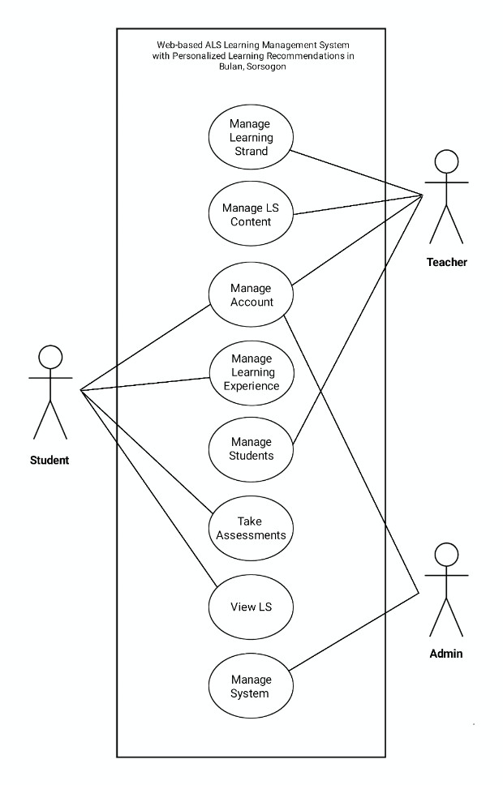

Figure 4.2 Use Case Diagram of the Proposed System (Level 0)

Figure 4.2 presented the level 0 or the high-level view of the system's functionality. The system has three (3) different actors including the students, teachers, and the admin together with the activity cases and their relationships. Students are actors that access, view and take within the course, including the management of their learning experiences and accounts. As for the teachers, they manage the LS (learning strand), LS content, enrollment of students and, managing their accounts. Meanwhile, admin manages the whole functionality of the system to maintain its functionalities.

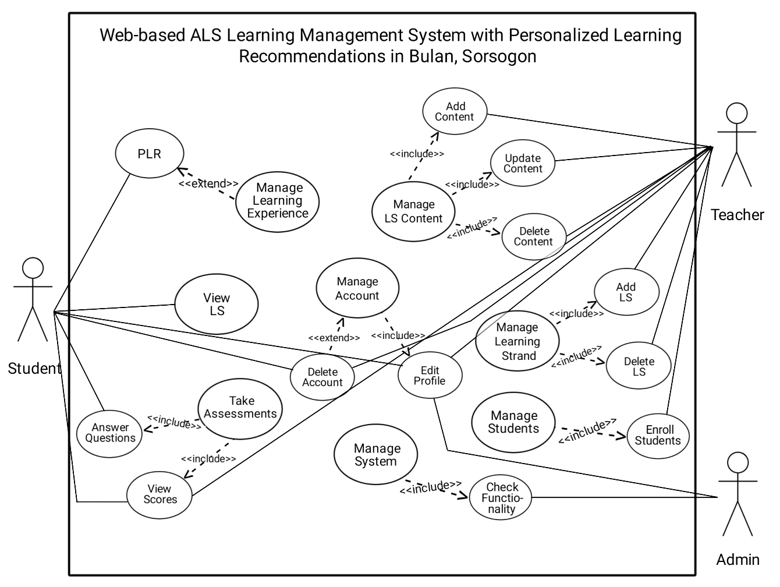

Figure 4.3 Use Case Diagram of the Proposed System (Level 1)

Figure 4.3 presented the detailed view of the system. In this level the, all users can manage their account including the editing of profile and deletion of their accounts. The specific use cases of the student are responsible for viewing learning strand, taking assessments and the system personally recommends a learning materials for only to students for their learning experience. The teachers are responsible for adding, updating and deleting learning strand as well as its contents. The enrollment of students is also the responsible of teachers. As for the admin, maintaining the functionality of the system by checking its whole functionalities.

### 4.2.2 Class Diagram

A class diagram is a visual representation of classes of the proposed system. It describes class structure, attributes, specifications and behavior, especially the relationships among system classes. On the other hand, class diagrams are static structure diagrams visualized and model Object-Oriented systems [26].

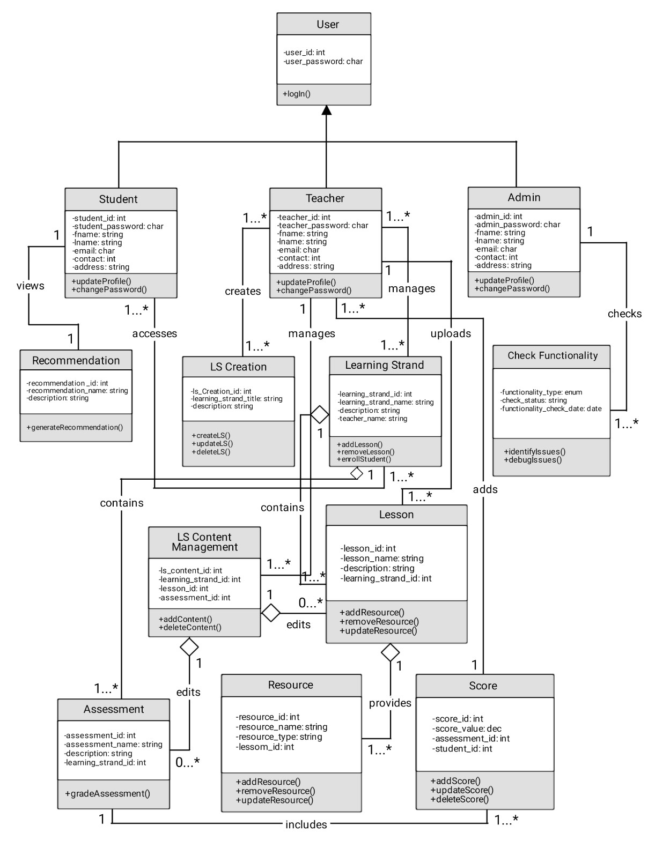

Figure 4.4 Class Diagram of the Proposed System

Figure 4.4 presented the structural diagram of the proposed system. The figure shows three users who manage different classes, attributes and behavior connected to system classes. Student class is connected to various classes, including learning strands following the recommendation class. For teachers, they will create their own learning strands, manage learning strands content consisting of lessons, resources, assessment and assignments along with the scores. Moreover, the admin of the system consists of check functionality class that has identify and debug issues behavior. Each user has a different type of link labeled by roles and multiplicity to show their relationships.

### 4.2.3 Activity Diagram

Activity Diagram referred to as a behavioral diagram is a type of UML flowchart that shows the flow from one activity to another in a system. It describes the different dynamic aspects of the system. Moreover, this shows the individual steps in an activity and its order starting from the initial state to the final state. Every activity diagram includes an action, decision, mode, control flows, start models, and end mode shown in the figure [24]. Activity diagram helps understand and model the process, workflows and users’ interaction [27]. Figures 4.5 to 4.7 presented the flow of the activities within the users and the LMS system. The different users occurred in the system using the swim lane activity diagram.

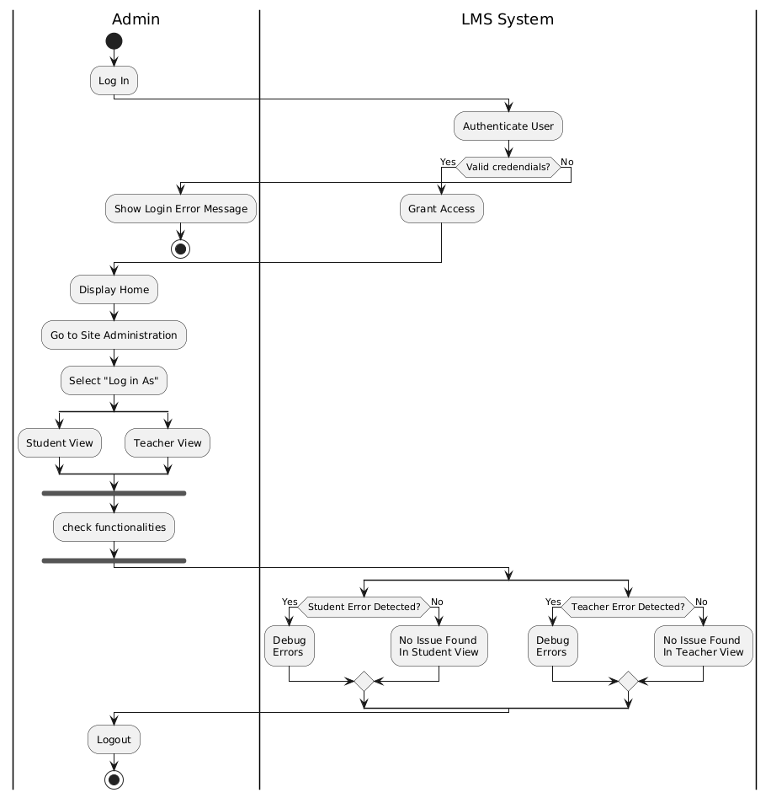

Figure 4.5 Admin Activity Diagram

Figure 4.5 showed the activities of the Admin. The system will validate log in to ensure that the user's log in is valid or not. The admin can access the dashboard and site administration when checking the functionality of the system of each user selecting "log-in as" student or teacher. Also, the admin has the authorization to debug issues or maintain the systems functionalities.

Figure 4.6 Teacher Users Activity Diagram

Figure 4.6 showed the activities of the teachers in the diagram. Teacher can access and manage learning strands, manage lessons, activities and assessments inside the learning strands once the log in of teacher is valid. They can add scores to the activities of students, upload resources in their lessons in any resource type and the system will validate it.

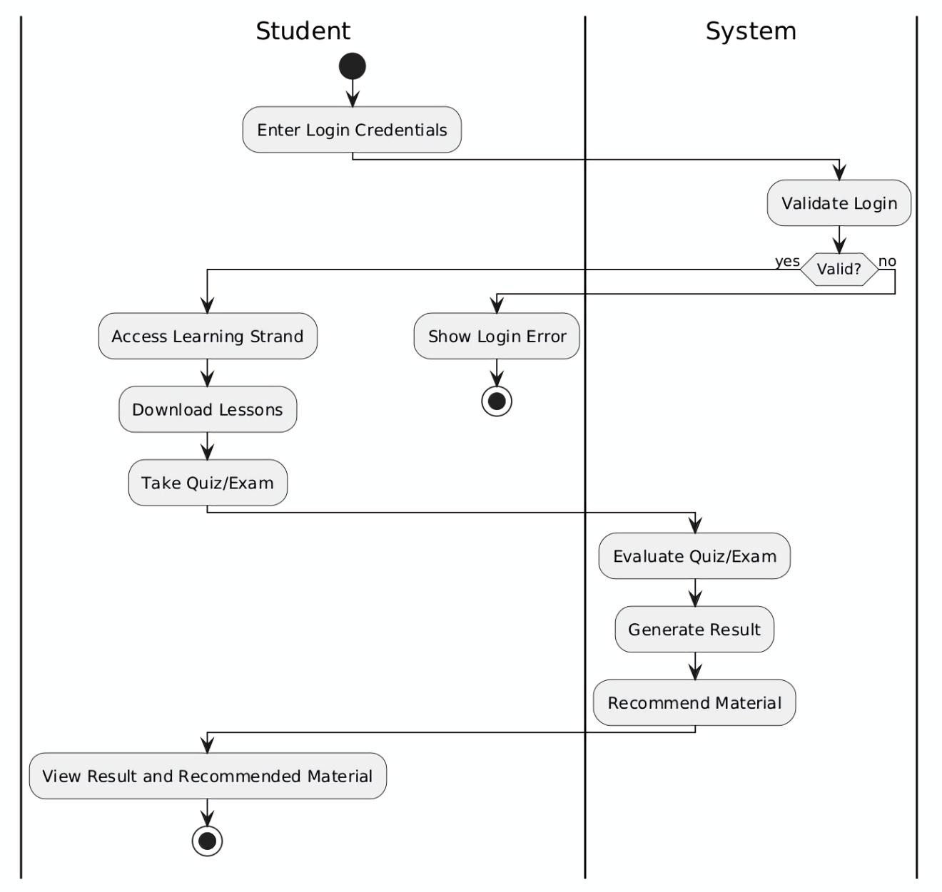

Figure 4.7 Student Users Activity Diagram

Figure 4.7 showed the activity diagram of students. Students will log in with their valid credentials to access the learning strands they are enrolled, download lessons and take assessments uploaded by their teachers. After the assessment, the system will evaluate the assessment, generate its result, and students can view and access the recommended material personally as it is the main feature or focus of this system.

### 4.2.1. Requirement Analysis

Requirements analysis is a crucial step in developing web applications, as it helps identify the needs and expectations of the client or users regarding the applications features, functions, and overall flow [30]. Using an Object-oriented Approach for analysis and design, the tables below outline the Functional and Non-Functional Requirements that the system was designed to meet.

#### 4.2.1.1 Functional Requirements

Functional Requirements presents the product features that developers must implement in the system and to facilitate users in achieving their objectives [28]. Table 4.1 presents the Functional Requirements of the proposed system specifically its task description and task reference. These functional requirements were closely linked to the objectives of this study.

Table 4.1 Functional Requirements

Task Requirement Task Reference

|  |  |
| --- | --- |
| The system should enable the teachers to create, manage, and delete learning activities. | Management of Activity, Assessment and scores |
| The system should be able to generate a general assessment for students to be aligned with their Learning strands. | Recommendation Engine |
| The system should be able to share contents and learning materials created by the teachers. | File Resource Sharing |

#### 4.2.1.1 Non-Functional Requirements

Non-functional Requirements (NFRs) are commonly distinguished from

words, non-functional requirements are not related to the system’s functionality but rather define how the system should perform [2]. Table 4.2 presented the non-functional requirements of the systems. The description of each requirement and its task reference were also presented. The stated reference was adapted from the software quality standards of the International Organization for Standardization, specifically in ISO/IEC 25010.

Table 4.2 Non-Functional Requirements

Task Requirement Task Reference

|  |  |
| --- | --- |
| The system should be able to perform and deliver all the functional requirements and provide the appropriate results. | Functional Suitability |
| The system should provide a clear and accessible navigation for both students and ALS teachers. | Interaction Capability |
| The system should be stable and available. It must handle multiple users without users’ degradation. | Reliability |

## 4.3 Development Model

The proposed system will be using Agile Methodology for its design and

development. Agile Methodology is an iterative approach that focuses on flexibility, collaboration, and continuous improvement to the software development and project development that breaks down work into smaller, manageable cycles called sprint, allowing the teams to quickly respond to change and deliver incremental value [33]. This methodology is compatible with the development of the proposed system as the design and structure will depend on the suggestions or future suggestions of the client.

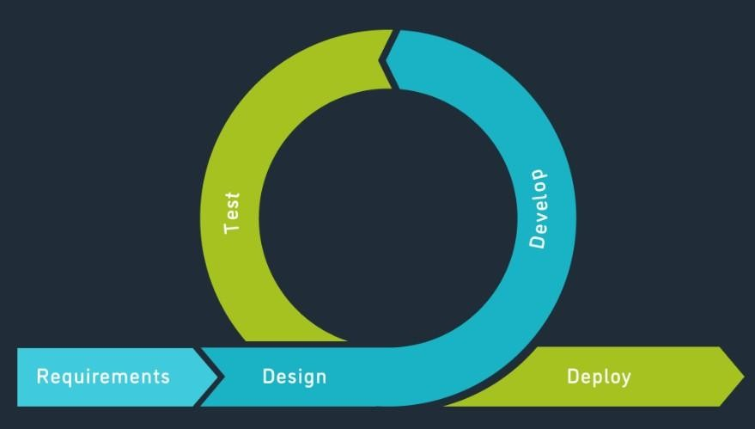

Figure 4.5 Agile Methodology

The following are the phases of Agile Methodology.

Requirements. This phase will be the proponents and clients communicate through a face-to-face interview to consult and determine the current problem that needs to be addressed. To fulfill this phase, the proponents visited Bulan National High School’s ALS program to gather data for our proposed capstone project entitled “Web-based ALS Learning Management System with Personalized Learning Recommendation”. During an interview with the Head teacher of ALS, which is Ma’am Karen Pura, the proponents discussed about the conducting capstone project and start asking about ALS. Based on the gathered data, the proponents drafted the

introduction discussing the project context, purpose and description, objectives of the study, and its scope and limitations. In addition, the proponents also gathered to research for existing systems to support our proposed system and defined the technical background including hardware and software requirements.

Design. In this phase, the proponents started to write the design and methodology chapter. The proponents begin first with a sketched for the design of the system, such as its system architecture and UML diagrams including the Use case with level 0 and level 1 diagram, Swimlane Activity diagram for students, teachers and Admin presenting its visual flow of the transactions happen on the system. Lastly, the Class diagram wherein discussed the relationships between classes. Then, the system analyst of the team edited the sketched designs in Adobe photoshop version 21.2 while the other members of the team making a brief explanation of each diagram. After, the job of technical writer appears as the encoder of the group, arranging the format for the papers.

The Agile methodology and top-down approach also decided by the team to use for the methodology and development approach since it is fit in the development of the proposed system.

Develop. The developer of the team together with its members structured the format of the code as the team begin to program the front-end development of log-in module and home module of the system using the Bootstrap, HTML5, CSS, and JavaScript for its responsive web design. Following the steps taken by the team, the developer for back-end development composed the code format for its functionality aligned with the front-end design then proceed composing of databases for storing the data.

Test. A different testing methods including unit testing, integration testing, and system testing will use by the proponents. The developed system undergoes unit testing for verifying individual components functionality and identify bugs or errors early. Next, the integration testing used by the team to validate interactions between modules of the LMS. Lastly, system testing wherein evaluated the overall performance and usability of the system.

Deploy. After all the phases are completed, the software will be deployed and maintained to the ALS Senior High School at BNHS (Bulan National High School) in Bulan, Sorsogon to be used by the prospective admin, ALS teachers and ALS senior high school students. The maintenance of the software was required for debugging and other software issues.

## 4.4 Development Approach

The system will use the top-down development approach as it is the recommended approach since our proposed system has a client and will use the iterative Agile Methodology. The top-down approach is a strategy where the decision-making process starts or occurs at the highest level and collaborates with stakeholders and the rest of the team [13]. So that, the proponents will start a plan by determining and identifying a possible critical requirement and features needed for the development of an effective system and then start to build or develop the system. After that, test the developed system collaborating with the clients and review their suggestions. This cycle will continue until the clients meet their satisfaction and proponents reach their goal. In addition, the development approach will be used in the proposed system because of its compatibility with the Object-Oriented approach.

## 4.5 Software Development Tools

The following were software development tools and applications that were used for developing the system:

### 4.5.1 Front-End Development

* HTML5. It is used as the foundation for structuring the content and pages of our system. Given that the platform includes components like student dashboards and lesson modules, HTML5 allows us to build a clean structure with modern elements like <section>, <nav>, and <video>—important for
* interactive content and modular design within our learning management system (LMS). According to Ashtari [16] It is the fifth version of the Hypertext Markup Language (HTML), used by web browsers to visualize code. It features several improvements in website capabilities, web content development, and more.
* CSS (Cascading Style Sheets). CSS styles the user interface of our system to ensure it is visually engaging and accessible. For ALS learners, an intuitive and clear interface is essential. CSS allows us to customize layouts and maintain visual consistency across features like quizzes and learner profiles —enhancing overall usability for both learners and instructors. Cascading Style Sheets and it is a fundamental technology in web development that plays a significant part in shaping websites’ visual appearance and layout. It empowers developers to carefully adjust the visual aspects of web pages including colors, fonts, layouts, backgrounds, and borders [17].
* Bootstrap 5. To ensure that the LMS is responsive and accessible across various devices, especially mobile phones, which many ALS learners use. Bootstrap 5 provides ready-to-use components like responsive navigation bars, collapsible menus, and form templates. This helps our team deliver a functional and mobile-first design without building everything from scratch. A free, open-source front-end development framework for the creation of websites and web apps. Designed to enable responsive development of mobile-first websites, Bootstrap provides a collection of syntax for template design [18].
* JavaScript. JavaScript brings interactivity to our platform. Features like instant feedback in quizzes and personalized learning recommendations based on user behavior are made possible with JavaScript. This supports our goal of creating a dynamic and engaging experience for ALS learners.

It is a versatile tool that adds interactivity to web pages and creates animations. In fact, it is used in a variety of applications, including Web and Mobile development, Game development, Virtual Reality (VR), and Artificial Intelligence (AI) [19].

### 4.5.2 Back-End Development

* PHP 8.1. It handles server-side logic such as processing quiz results, managing user sessions, and interacting with the database to retrieve or store learner information. With new features like performance improvements and read-only properties, PHP 8.1 ensures that our system remains secure, fast, and maintainable.

PHP-based (Hypertext pre-processor is a general-purpose scripting language used to develop dynamic and interactive websites) learning management system (LMS) that is free and open source [15].

* Laravel 10. Laravel simplifies the development of complex features such as role-based access (e.g., teacher vs. learner), user authentication, and routing between modules. For our system, which involves
* managing multiple user roles and personalized recommendations, Laravel’s clean MVC structure and built-in tools greatly improve development speed.

A free open-source PHP framework. It provides web developers tools and resources for building modern PHP web applications [22].

* MySQL 8.4. It serves as the core database where learner profiles, lesson content, quiz data, and recommendation logs are stored. Its ability to handle structured data efficiently supports our system’s need for quick retrieval and updates, especially for personalized recommendations.

The world’s most popular open-source database management system. It is a SQL-Based relation database designed to store and manage structured data [20].

* XAMPP. XAMPP provides a local development environment that includes Apache, MySQL, and PHP, enabling us to build and test the entire system offline. It’s particularly helpful for rapid prototyping, debugging, and integrating components before deployment to a live server.

### 4.5.3 Text editor and IDE

- Visual Studio Code 1.97. Our team uses Visual Studio Code as the primary integrated development environment (IDE) due to its powerful features like IntelliSense, live debugging, and integrated terminal. Extensions such as PHP Intelephense and Laravel Blade Snippets improve productivity and ensure consistent coding practices throughout the project.

Is a lightweight yet powerful code editor developed by Microsoft, design to make coding easier and more efficient [21].

### 4.5.4 Version Control System

- Git. Git is essential for version control and team collaboration. As our team works on different modules (e.g., learner dashboard, teacher analytics, admin settings), Git allows us to work concurrently, track changes, and roll back safely if issues arise. This is crucial for managing a project of this scale with multiple contributors.

## 4.6 Schedule and Timeline

Figure 4.6 shows a visual overview of the project schedule, highlighting the timeline, specific tasks, and their dependencies. The project is planned to be developed over two academic semesters, namely the 2nd semester of the school year 2024-2025 and 1st semester of the school year 2025-2026.

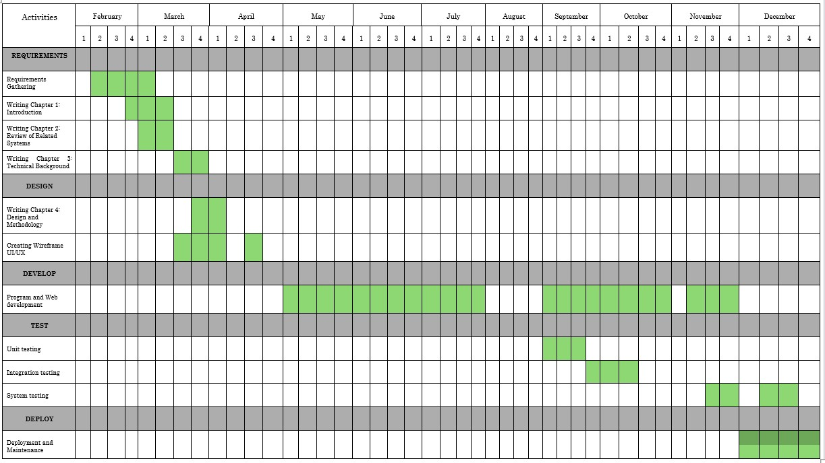

Table 4.3 Development Timeline

The proponents discussed the title that best fits for our capstone project and identified the possible problems inside the organization of our clients. Following that, the stages of the methodology used in this project will be conducted including requirements, design, development, test and deployment. The requirements phase is the time for proponents to gather requirements, writing the Introduction (Chapter 1), Review of Related System (Chapter 2) and the technical background (Chapter 3).

The next phase is writing the design and methodology for chapter 4. The chapter includes the concept, design and analysis, requirement analysis, development model, the software development tools used and other compositions of this chapter together with different diagrams and tables are also presented. Furthermore, the wireframe design of the system will then be created to visualize the structure and design.

After designing, program and web development of proposed system will start on the third phase that is crucial component of the capstone project. The developer of the team, the system analyst and other team members will develop the structure of the system within 3 to 6 months. Applying the design efficiently and developing a system that meets the objectives of this project.

The fourth phase is the test or the testing of the system during and after its development. The testing will be conducted frequently or every time the proponents develop a new component of the system to test whether it properly functions or needs a debugging to ensure that the users meet its requirements and add the user's suggestions or feedback in the system.

Lastly, the deployment and maintenance phase will start to execute after the iteration process is succeeded. The system will be prepared for deployment process and undergo maintenance several times to make sure it's interaction capability, performance efficiency, security and reliability.

## 4.7 Responsibilities

In this capstone project, composed of four IT students who worked as a team with designated roles aligned in developing and designing a web-based

learning management system with personalized learning recommendations. Responsibilities of each role were further discussed in this section.

Ronil Malapote, Project Leader. Responsible for strategic management tasks, project planning and decision making. Mr. Malapote can ensure that the group aligns with the proposed project providing team support and effective coordination.

Francine F. Gludo, System Analyst. Responsible for monitoring, maintaining and improving existing systems for users and clients. Studies various components to identify the system’s objective and ensures that every component is developed to accomplish the objectives of the system. Ms. Gludo is assigned as a system analyst to improve the efficiency, effectiveness and functionality of the system. It helps organizations optimize their processes, make informed decisions, and achieve their goals.

Jhonpaul G. Corong, Software Engineer. The responsibilities of Software Engineer will be to develop and design a web-based system that meets the user’s requirements and the objectives of the system. They will work closely with the project manager, system analyst, and other team members to ensure that the software meets the needs and specifications of the project. Mr. Corong will be responsible for producing high-quality software systems that meet the project objectives and contribute to the project’s success.

Wilfredo Jr H. Magollado, Technical Writer. The Technical writer will be responsible for preparing, reviewing, revising and maintaining the technical papers and documents of the project and for the decision required in creating features needed for users. Mr. Magollado ensures that the project documentation is clear, concise, accurate and meets the needs of all the relevant parties.

## 4.8 Budget and Cost Management

This project needed a budget to cover the materials, supplies, services, maintenance, and other operating expenses required for both system development and documentation. Below is a table list of the estimated costs and how the budget was used.

Table 4.4 Materials and Supplies Budgetary Requirements

|  |  |  |  |
| --- | --- | --- | --- |
| Item | Quantity | Price | Amount |
| Bond Paper (Hard Copy 70 gsm, 500 sheets, letter) | 3 | Php 200.00 | Php 600.00 |
| Ink (Epson L3110 Ink 003) | 1 set (4 pieces) | Php 1,000.00 | Php 1,000.00 |
| Laptop | 1pc | Php 47,000.00 | Php 47,000.00 |
|  |  | Total amount: | Php 48,600.00 |

Table 4.4 presents the estimated cost of essential materials and equipment required throughout the project. These include both consumables and a key hardware component. Three reams of bond paper (70 gsm, letter size, 500

sheets each) are budgeted at Php 600.00 for printing project documentation and other hard copy needs. A complete set of Epson L3110 Ink 003, priced at Php 1,000.00, supports all printing activities during the development phase.

Additionally, a laptop is included in the budget, with a cost of Php 47,000.00. This unit serves as the primary development tool for system design, coding, testing, and documentation. The total projected expense for materials and supplies amounts to Php 48,600.00, ensuring both administrative and technical tasks are well-supported.

Table 4.5 Services Budgetary Requirements

|  |  |  |  |  |
| --- | --- | --- | --- | --- |
| **Service** | **Duration** | **Price** | | **Amount** |
| Internet Service | 11 months | Php. 699.00 | | Php 7,689.00 |
| Web and Cloud Hosting | | | Free |  |
|  | | | **Total amount:** | Php 7,689.00 |

Table 4.5 details the cost of internet connectivity, which is a critical service throughout the capstone project. Internet access enables online collaboration, system testing, access to cloud-based tools, and communication with stakeholders. The subscription, priced at Php 699.00 per month, spans 11 months—aligned with the project’s expected timeline. The total service expense is Php 7,689.00, providing reliable connectivity throughout the project's duration.

Table 4.6 Maintenance and Other Operating Expenses Budgetary

Requirements

|  |  |  |  |  |
| --- | --- | --- | --- | --- |
| Item | No. of Person | Duration | Price | Amount |
| Vehicular Fare | 2 | 10 months | Php 50.00 | Php 12,000.00 |
| Gas | 2 | 10 months | Php 60.00 | Php 14,400.00 |
|  |  |  | Total amount: | Php 26,400.00 |

Table 4.6 outlines the transportation-related expenses required to support logistical aspects of the project. This includes both public and private transportation, covering travel for meetings, site visits, and other projectrelated activities.

Vehicular fare for two team members over a 10-month period is estimated at Php 50.00 per person per day, amounting to Php 12,000.00. Similarly, a gasoline allocation is included at Php 60.00 per person per day, totaling Php 14,400.00. The combined budget for maintenance and operating expenses is Php 26,400.00, ensuring sufficient logistical support across the project timeline.

## 4.9 Verification and Validation

The proponents conducted verification and validation to ensure that the system has met the requirements of the client and to make sure the system was functioning as planned.

The system was reviewed and verified by the clients every iteration process since Agile methodology is an iterative approach. The proponents went personally to clients for inspection and examine each developed features and design. This process ensures that the recommended requirements were met and accurate to its specified requirements. The proponents utilized some

ISO/IEC 25010 including Functional Suitability, Interaction Capability, Security and Reliability to measure the developed system and for its validation. To validate, survey questionnaires were implemented for an effective assessment of client's responses and ratings.

## 4.10 Testing

Since the Web-based ALS Learning Management System is being developed using the Agile methodology, testing will be conducted gradually, based on the features available at each development stage. Although the full system is not yet fully implemented, the proponents plan to test key components as they are developed to ensure proper functionality and usability.

### 4.10.1 Beta Testing

Once the core features of the system such as user login, access to learning modules, quiz functionality, and personalized learning recommendations are ready, a beta version will be shared with selected ALS teachers and learners in Bulan, Sorsogon. They will be encouraged to use the system in a way that simulates a real learning session. Their feedback will be used to identify any usability issues or suggestions for improvement. For example, users might find certain parts of the interface unclear or may experience minor bugs. These insights will guide the proponents in making necessary adjustments and enhancements before the system is fully deployed. This beta testing phase will allow for early feedback from actual users, which is a key part of Agile development. It ensures that the system is being improved in response to the real needs of its users.

### 4.10.2 Additional Testing

In addition to beta testing, the proponents will conduct several technical tests to verify the system’s reliability:

Unit Testing: Each individual feature such as user authentication, module upload, and quiz generation will be tested on its own to ensure it works correctly.

Integration Testing: Once modules are completed, they will be tested together to check if data flows smoothly between features, like syncing user progress with personalized recommendations.

System Testing: The entire system will be tested once all major features are in place. This will help identify any system-wide issues and confirm that everything works together as expected.

# BIBLIOGRAPHY

1. S.K.R. Kankunta. "Online Learning Management System." Open Portal to University Scholarship. [https://opus.govst.edu](https://opus.govst.edu/?fbclid=IwZXh0bgNhZW0CMTAAAR72SBT_yqj49EIJklHoxPoJGUL76jGgeZt9zLZVF8uQvgek8iKXAb-sQFmFnQ_aem_bNtpQnIbviYZ_zRJuKx1Cw) [accessed Feb. 7, 2025]
2. M.S. Delos Santos, D. Durano, A. Hortillosa. "The Development of a Proposed Learning Management System for Senior High Schools in the Philippines." International Journal of Information and Education Technology. [https://www.ijiet.org](https://l.facebook.com/l.php?u=https%3A%2F%2Fwww.ijiet.org%2F%3Ffbclid%3DIwZXh0bgNhZW0CMTAAAR7jRjU6N2WNb7Kjj9FJp59co8oah6fyVwu_woeAl8UcFywBBc2PPjLiQj-rfQ_aem_j2Q9TZqdjAFuim4H-iYBrQ&h=AT1toDmY7W2RxnxbnCSsfco40ZwiL6GqMrL8ZGRTTVfnl7WrwDb944QiEqKCUvja93k45vLS8pHhaetfpy0mcms_kYvbjJU1Op3bGb2W6PhU6bBoHQ7bH4d3fesZneZ1OsglKQ) [accessed Feb 9, 2025]
3. K. Bhavadharini, K. Charulata. " E-LEARNING MANAGEMENT SYSTEM." Sathyahama Institute of Science and Technology.

[https://sist.sathyahama.ac.in](https://l.facebook.com/l.php?u=https%3A%2F%2Fsist.sathyahama.ac.in%2F%3Ffbclid%3DIwZXh0bgNhZW0CMTAAAR7HlZl3UXEvRNVvI9NPL8SIUBolChE8cgfNJf-TZFTdFhTaRhqr6y2YeY-B_g_aem_8nc-dsOU5rFo2H_JpHbXFQ&h=AT1toDmY7W2RxnxbnCSsfco40ZwiL6GqMrL8ZGRTTVfnl7WrwDb944QiEqKCUvja93k45vLS8pHhaetfpy0mcms_kYvbjJU1Op3bGb2W6PhU6bBoHQ7bH4d3fesZneZ1OsglKQ) [accessed Feb. 8, 2025]

1. J.P. Widodo, L. Musyarofah, J. Slamet. "Developing A Moodle-based Learning Management System (LMS) for Slow Learners." Jurnal

Inspirasi Pendidikan. [https://www.academia.edu](https://l.facebook.com/l.php?u=https%3A%2F%2Fwww.academia.edu%2F%3Ffbclid%3DIwZXh0bgNhZW0CMTAAAR400lZ-jNrhmKBP_-wBvdlT9jnvglELiJa3B2Yx6dRsbvJjUcbA0oEQt-V-Gw_aem_s7mrB_r8kWhzQ5jxaSeCFg&h=AT1toDmY7W2RxnxbnCSsfco40ZwiL6GqMrL8ZGRTTVfnl7WrwDb944QiEqKCUvja93k45vLS8pHhaetfpy0mcms_kYvbjJU1Op3bGb2W6PhU6bBoHQ7bH4d3fesZneZ1OsglKQ) [accessed March 2, 2025]

1. V.M. Bradley. "Learning Management System (LMS) Use with Online Instruction." International Journal of Technology in Education. [https://doi.org](https://l.facebook.com/l.php?u=https%3A%2F%2Fdoi.org%2F%3Ffbclid%3DIwZXh0bgNhZW0CMTAAAR7WW_j4lzVw2Jum5ZTMxsb9vwThVCjpsADaib_JrBWrq1n64TPFz-zS5lkFyQ_aem_0nRyvtaw4_f0YGE6oLs75g&h=AT1toDmY7W2RxnxbnCSsfco40ZwiL6GqMrL8ZGRTTVfnl7WrwDb944QiEqKCUvja93k45vLS8pHhaetfpy0mcms_kYvbjJU1Op3bGb2W6PhU6bBoHQ7bH4d3fesZneZ1OsglKQ) [accessed March 3, 20245]
2. A.A.H. Alia. "The Analysis of a Learning Management System from a Design and Development Perspective." International Journal of

Information and Education Technology. [https://www.ijiet.org](https://l.facebook.com/l.php?u=https%3A%2F%2Fwww.ijiet.org%2F%3Ffbclid%3DIwZXh0bgNhZW0CMTAAAR7o8a7ZEBXAxQ1kmXNjdPGdsH80Hpk8CQx3HYJ93qg20YrbvRvzis8DImDYkQ_aem_c1dXva6q8m66-57b6wn4WA&h=AT1toDmY7W2RxnxbnCSsfco40ZwiL6GqMrL8ZGRTTVfnl7WrwDb944QiEqKCUvja93k45vLS8pHhaetfpy0mcms_kYvbjJU1Op3bGb2W6PhU6bBoHQ7bH4d3fesZneZ1OsglKQ) [accessed March 9, 2025]

1. I. Suartama, P. Setyosari, S. Sulthoni, S. Ulfa. "Development of Ubiquitous Learning Environment Based on Moodle Learning Management System." The Learning and Technology Library. [https://www.learntechlib.org](https://www.learntechlib.org/?fbclid=IwZXh0bgNhZW0CMTAAAR5fQrDPyPpLROAUcbl6ixzpvNmlkSeP8Xgt9hu66sOjt8xQAQlEzlIWCynPlQ_aem_gVJldh4u0AHj-Dpe84DTdQ) [accessed March 2, 2025]
2. Y. Lahmadi, M. Ovadoud, H. Mouzouri, L. Oughdir. "Modeling of WebBased Collaborative Learning Management System." Indonesian Journal of Electrical Engineering and Computer Science.

[https://ijeecs.iascore.com](https://ijeecs.iascore.com/?fbclid=IwZXh0bgNhZW0CMTAAAR5fQrDPyPpLROAUcbl6ixzpvNmlkSeP8Xgt9hu66sOjt8xQAQlEzlIWCynPlQ_aem_gVJldh4u0AHj-Dpe84DTdQ) [accessed March 3, 2025]

1. A. De Castro, B. Rico, K. Pineda. " Learning Management System Using PHP and MySQL." SCRIBD. [https://www.scribd.com](https://www.scribd.com/?fbclid=IwZXh0bgNhZW0CMTAAAR7WW_j4lzVw2Jum5ZTMxsb9vwThVCjpsADaib_JrBWrq1n64TPFz-zS5lkFyQ_aem_0nRyvtaw4_f0YGE6oLs75g) [accessed March 5, 2025]
2. G. R, A. Sabu, A. M. Varghese, A. S. Kurian, R. Mathews. "CALIFYN -

LEARNING MANAGEMENT SYSTEM." International Journal of

Engineering and Technology. [https://www.irjet.net](https://l.facebook.com/l.php?u=https%3A%2F%2Fwww.irjet.net%2F%3Ffbclid%3DIwZXh0bgNhZW0CMTAAAR5fQrDPyPpLROAUcbl6ixzpvNmlkSeP8Xgt9hu66sOjt8xQAQlEzlIWCynPlQ_aem_gVJldh4u0AHj-Dpe84DTdQ&h=AT1toDmY7W2RxnxbnCSsfco40ZwiL6GqMrL8ZGRTTVfnl7WrwDb944QiEqKCUvja93k45vLS8pHhaetfpy0mcms_kYvbjJU1Op3bGb2W6PhU6bBoHQ7bH4d3fesZneZ1OsglKQ) [accessed March 6, 2025]

1. N. Aulianda, P. H. Wijayati, M. Ebner, S. Schön. "The Analysis of Learning Management System towards Students' Cognitive Learning Outcome." International Journal of Emerging Technologies in Learning.

[https://online-journals.org](https://l.facebook.com/l.php?u=https%3A%2F%2Fonline-journals.org%2F%3Ffbclid%3DIwZXh0bgNhZW0CMTAAAR7HlZl3UXEvRNVvI9NPL8SIUBolChE8cgfNJf-TZFTdFhTaRhqr6y2YeY-B_g_aem_8nc-dsOU5rFo2H_JpHbXFQ&h=AT1toDmY7W2RxnxbnCSsfco40ZwiL6GqMrL8ZGRTTVfnl7WrwDb944QiEqKCUvja93k45vLS8pHhaetfpy0mcms_kYvbjJU1Op3bGb2W6PhU6bBoHQ7bH4d3fesZneZ1OsglKQ) [accessed March 16, 2025]

1. R. Rabinan, M. Nurtanto, N. Kholifaf. "Design and Development ELearning System By Learning Management System (LMS) In Vocational Education." International of Scientific and Technology Research. [https://files.eric.ed.gov](https://files.eric.ed.gov/?fbclid=IwZXh0bgNhZW0CMTAAAR400lZ-jNrhmKBP_-wBvdlT9jnvglELiJa3B2Yx6dRsbvJjUcbA0oEQt-V-Gw_aem_s7mrB_r8kWhzQ5jxaSeCFg) [13] Asana. "Top-down approach Vs. bottom-up approach: What's the difference?" asana. [https://asana.com](https://l.facebook.com/l.php?u=https%3A%2F%2Fasana.com%2F%3Ffbclid%3DIwZXh0bgNhZW0CMTAAAR7HlZl3UXEvRNVvI9NPL8SIUBolChE8cgfNJf-TZFTdFhTaRhqr6y2YeY-B_g_aem_8nc-dsOU5rFo2H_JpHbXFQ&h=AT1toDmY7W2RxnxbnCSsfco40ZwiL6GqMrL8ZGRTTVfnl7WrwDb944QiEqKCUvja93k45vLS8pHhaetfpy0mcms_kYvbjJU1Op3bGb2W6PhU6bBoHQ7bH4d3fesZneZ1OsglKQ) [accessed

March 28, 2025]

1. L. Singla. "What is PHP for Web Development and Why Should You Use It?" net solutions. [https://www.netsolutions.com](https://l.facebook.com/l.php?u=https%3A%2F%2Fwww.netsolutions.com%2F%3Ffbclid%3DIwZXh0bgNhZW0CMTAAAR7WW_j4lzVw2Jum5ZTMxsb9vwThVCjpsADaib_JrBWrq1n64TPFz-zS5lkFyQ_aem_0nRyvtaw4_f0YGE6oLs75g&h=AT1toDmY7W2RxnxbnCSsfco40ZwiL6GqMrL8ZGRTTVfnl7WrwDb944QiEqKCUvja93k45vLS8pHhaetfpy0mcms_kYvbjJU1Op3bGb2W6PhU6bBoHQ7bH4d3fesZneZ1OsglKQ) [accessed March 30, 2025]
2. Asana. "Top-down approach Vs. bottom-up approach: What's the difference?" asana. [https://asana.com](https://asana.com/?fbclid=IwZXh0bgNhZW0CMTAAAR7HlZl3UXEvRNVvI9NPL8SIUBolChE8cgfNJf-TZFTdFhTaRhqr6y2YeY-B_g_aem_8nc-dsOU5rFo2H_JpHbXFQ) [accessed March 28, 2025]
3. E. Bevola, M. Arkhipova, O. Mineevo, Y. Gavvikova, M. Liashenko. "Management of Students' Independent Work Through Moodle Learning Management System." The European Proceeding of Social and

Behavioral Sciences. [https://www.europeanproceedings.com](https://www.europeanproceedings.com/?fbclid=IwZXh0bgNhZW0CMTAAAR7wVR4ZPO2QnZTc6j8hNTi--ZvJmCBSUDu7fXvFbxHjJpZXAD6wCN3gmsulmw_aem_VBixxtUVAVsNiHk8Djz7hQ) [accessed March 30, 2025]

1. H. Ashtari.” What is HTML5?” Meaning, Elements, and Benefits.” Spiceworks. https://spiceworks.com [accessed March 30, 2025]
2. Skills. “Importance of CSS in Web Development.” Skills. [https://pwskills.com](https://pwskills.com/) [accessed March 30, 2025]
3. A.Zola. “What is Bootstrap.” TechTarget and Informa Tech’s. [https://www.techtarget.com](https://www.techtarget.com/) [accessed March 30, 2025]
4. Coursera. “What is JavaScript Used for.” Coursera. [https://www.coursera.org](https://www.coursera.org/) [accessed March 30, 2025]
5. J. Erickson. “MYSQL: Understanding What it is and How it’s Used.” Oci. [https://www.oracle.com](https://www.oracle.com/) [accessed March 30, 2025]
6. M. Heller. “What is Visual Studio Code? Microsoft’s extendible code editor.” InfoWorld. [https://www.infoworld.com](https://www.infoworld.com/) [accessed March 30, 2025]
7. A. Jalli. “What is Laravel.” Builtin. [https://builtin.com](https://builtin.com/) [accessed March

31, 2025]

1. Lucidchart. “UML Use Case Diagram Tutorial”. Lucidchart. [https://www.lucidchart.com](https://www.lucidchart.com/) [accessed April 1, 2025]
2. MindManager. “What’s an Activity Diagram?” MindManager. [https://www.mindmanager.com](https://www.mindmanager.com/) [accessed April 1, 2025]
3. LucidChart. “Introduction to class diagrams”. LucidCharts. [https://www.lucidchart.com](https://www.lucidchart.com/) [accessed April 1, 2025]
4. N. Patel. “Understanding Activity Diagrams: A Vital Guide to System

Process Modeling”. Medium. [https://medium.com](https://medium.com/) [accessed April 1, 2025]

1. Altexsoft. “Functional and Nonfunctional Requirements: Specification and Types”. Altexsoft. [https://www.altexsoft.com](https://www.altexsoft.com/) [accessed April 2, 2025] [28] K. Yasar. “What is web application (web apps) and its benefits?”. Informa. [https://www.techtarget.com](https://www.techtarget.com/) [accessed April 2, 2025]
2. Simplilearn. “What is Requirement Analysis?”. Simplilearn. [https://www.simplilearn.com](https://www.simplilearn.com/) [accessed April 3, 2025]
3. A. Froehlich. “Presentation layer”. Informa. [https://www.techtarget.com](https://www.techtarget.com/) [accessed April 4, 2025]
4. Wikipedia. “Application Layer”. Wikipedia. [https://g.co](https://g.co/) [accessed April 4, 2025]
5. Asana. “What is Agile Methodology? (A beginner’s guide). Asana. [https://asana.com](https://asana.com/) [accessed April 4, 2025]
6. PHP. “Laravel running requirements”. PHP. <https://m.php.cn/faq/544968.html>[accessed April 9, 2025]
7. Artikkeli. “System Requirements for the Microsoft Driver for PHP for SQL Server”. Skills-academy. [https://video2.skills-academy.com](https://video2.skills-academy.com/) [accessed April 9, 2025]
8. J. P. B. Saputra, H. Prabowo, F. L. Gaol. G. F. Hertomo.

“DEVELOPMENT OF GAMIFICTION-BASED LEARNING MANAGEMENT SYSTEM (LMS) WITH AGILE APPROACH AND PERSONALIZATION OF FSLSM LEARNING STYLE TO IMPROVE LEARNING EFFECTIVENESS”. Journal of Applied Data Sciences.

[https://doi.org](https://doi.org/) [accessed April 11, 2025]

References (IEEE Format)

1. A. Ashtari, "HTML5: The New Standard for Web Development," Journal of Web Technologies, vol. 10, no. 2, pp. 45-50, 2015.
2. W3C, "Cascading Style Sheets (CSS) Level 2 Revision 1 (CSS 2.1)

Specification," [Online]. Available: [https://www.w3.org/TR/CSS2/.](https://www.w3.org/TR/CSS2/) [Accessed:

May 15, 2025].

1. Bootstrap, "Bootstrap 5 Documentation," [Online]. Available:

https://getbootstrap.com/docs/5.0/. [Accessed: May 15, 2025].

1. Mozilla Developer Network, "JavaScript Guide," [Online]. Available: [https://developer.mozilla.org/en-US/docs/Web/JavaScript/Guide.](https://developer.mozilla.org/en-US/docs/Web/JavaScript/Guide) [Accessed:

May 15, 2025].

1. PHP.net, "PHP 8.1 Release Notes," [Online]. Available:

[https://www.php.net/releases/8.1/en.php.](https://www.php.net/releases/8.1/en.php) [Accessed: May 15, 2025].

1. Laravel, "Laravel 10 Documentation," [Online]. Available:

[https://laravel.com/docs/10.x.](https://laravel.com/docs/10.x) [Accessed: May 15, 2025].

1. MySQL, "MySQL 8.4 Reference Manual," [Online]. Available:

[https://dev.mysql.com/doc/refman/8.4/en/.](https://dev.mysql.com/doc/refman/8.4/en/) [Accessed: May 15, 2025].

1. Microsoft, "Visual Studio Code Documentation," [Online]. Available:

[https://code.visualstudio.com/docs.](https://code.visualstudio.com/docs) [Accessed: May 15, 2025].

1. Git SCM, "Git: Distributed Version Control System," [Online]. Available:

[https://git-scm.com/.](https://git-scm.com/) [Accessed: May 15, 2025].

1. Apache Friends, "XAMPP for Windows," [Online]. Available:

https://www.apachefriends.org/index.html. [Accessed: May 15, 2025].